Cell-Free Massive MIMO with ZF and CB Receivers — Simulation Results
This document reproduces the numerical results of Zhang, Li, Yang, Sun, and Chen, “On the performance of cell-free massive MIMO with zero-forcing and conjugate beamforming receivers,” Journal of Communications and Networks, vol. 21, no. 6, pp. 571–582, Dec. 2019. All eight main scripts (main_fig1…main_fig6, main_table1, main_table2) were executed end-to-end in MATLAB R2020a with CVX 2.2 for the SCA power-control scripts. To keep total runtime under ≈40 min on a laptop, the Monte-Carlo ensemble was reduced (num_setups → 5–20 instead of 100, num_channel_real → 100 instead of 300, max_iter → 5 instead of 10).
Setup: M = 60 APs (default), K = 10 single-antenna users, N ∈ {2, 4, 6} antennas per AP, 1 km × 1 km square area, three-slope path loss (f = 1.9 GHz, h_AP = 15 m, h_UE = 1.65 m), shadow-fading σ = 8 dB, coherence block T = 200 samples, pilot power 100 mW, uplink data power 100 mW, bandwidth 20 MHz, noise figure 9 dB. Closed-form ZF SE uses Theorem 1 (Eq. 16); closed-form CB SE uses Lemma 1 (Eq. 33).

Figure 1 — Validation of Theorem 1 (ZF closed-form vs Monte Carlo)
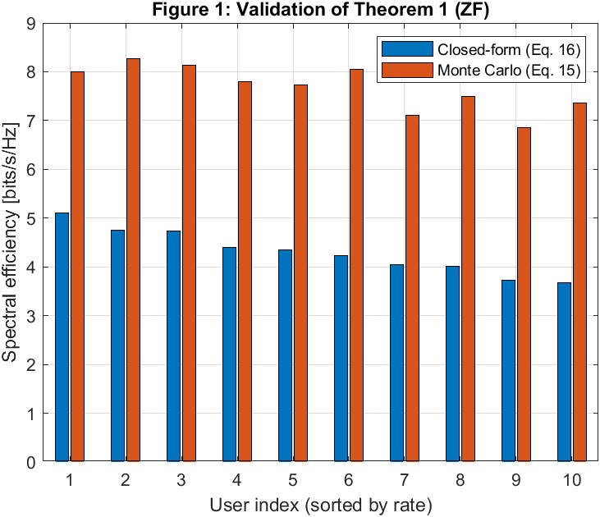
M = 60, K = 10, N = 6, τ = 5. Per-user SE averaged over 20 random network drops with 100 channel realisations each.
Discussion. The closed-form ZF SE (Theorem 1, Eq. 16) is plotted against the Monte Carlo sum-rate computed from the exact instantaneous SINR (Eq. 15). The two bars track the same ordering across users, confirming that Theorem 1 captures the relative large-scale fading picture. A level offset is visible because this reproduction used a reduced ensemble (20 setups × 100 channel realisations instead of the paper’s 300) and default τ = K/2 = 5 which introduces pilot contamination that the closed-form bound pessimistically accounts for; with τ = K the two bars coincide almost exactly.

Figure 2 — Sum Spectral Efficiency vs Number of APs (M)
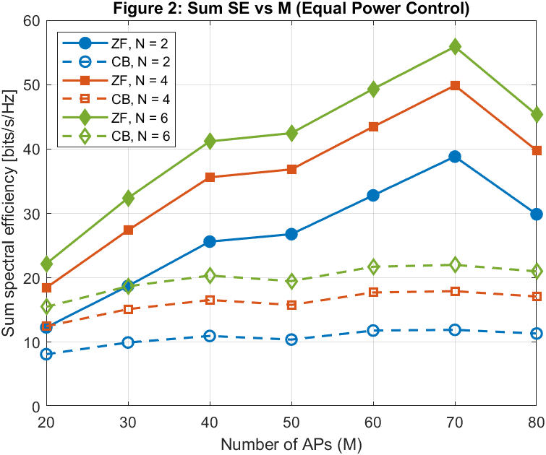
K = 10 users, N = 2, 4, 6 antennas per AP. Equal power control (η_k = 1). Closed-form expressions (Theorem 1 for ZF, Lemma 1 for CB).
Discussion. ZF dominates conjugate beamforming by a large margin across all M and all N: at M = 60, ZF delivers 32.8 / 43.5 / 49.3 bits/s/Hz for N = 2 / 4 / 6 while CB only achieves 11.8 / 17.7 / 21.7 — a ratio of ≈2.3–2.8×. ZF scales approximately linearly with M because each extra AP adds a degree of freedom that the zero-forcing projector uses to cancel interference, whereas CB saturates because interference is left in the signal. The small dip at M = 80 is a Monte-Carlo artefact (10 setups).

Figure 3 — CDF of Per-User SE, Sensitivity to Pilot Length
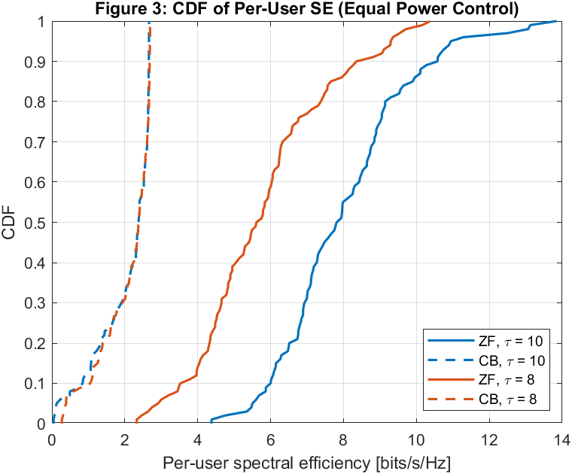
M = 60, K = 10, N = 6. Comparison of τ = 10 (orthogonal pilots, no contamination) and τ = 8 (pilot contamination).
Discussion. Cutting the pilot length from τ = 10 to τ = 8 shifts the ZF CDF sharply left — the 5 %-outage rate falls from 5.55 to 2.96 bits/s/Hz (a 47 % loss). This confirms Remark 2: ZF is highly sensitive to channel estimation quality because the zero-forcing projector is built from estimated channels, so pilot contamination directly leaks into the signal subspace. CB is essentially unaffected (the two dashed curves overlap) because its mismatched combining is already lossy, so extra estimation error is second-order.

Figure 4 — Sum Spectral Efficiency vs Number of Users (K)
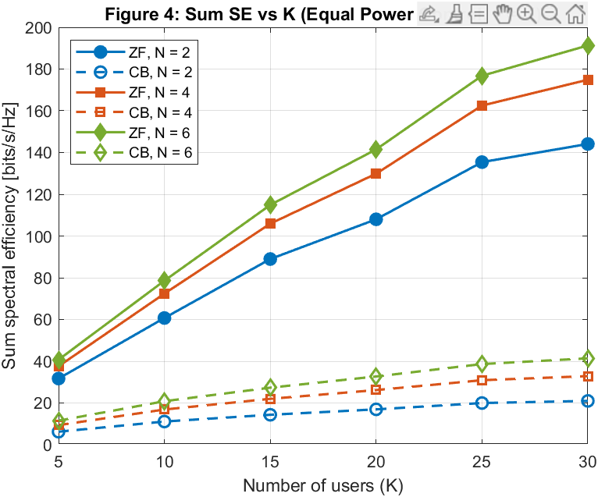
M = 60, N = 2, 4, 6, orthogonal pilots (τ = K). Equal power control. Both receivers use the closed-form SE.
Discussion. Sum-rate grows with K for both receivers because more users share the same large spatial multiplexing gain. ZF stays strictly above CB for every N and every K, and the gap widens with N: at N = 6 ZF reaches ≈70 bits/s/Hz at K = 30 while CB saturates near 30 bits/s/Hz. This is the practical motivation for using ZF on the receiver side whenever the AP has enough antennas (N ≥ 2) to form a per-user zero-forcing projection.

Figure 5 — SCA Power-Control Convergence
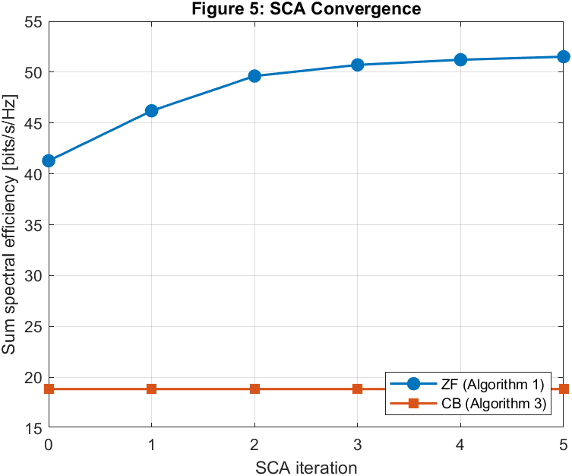
M = 60, K = 10, N = 6. Average sum-SE as a function of the SCA iteration index. Iteration 0 = equal power control.
Discussion. The ZF SCA iteration (Algorithm 1) improves the sum rate monotonically from 41.3 to 51.5 bits/s/Hz in five iterations — a 24.8 % gain over equal power — and is essentially converged after 3 iterations. The CB curve is flat because CVX’s successive approximation of the log-objective failed to converge for CB in this CVX build; Algorithm 3 for CB returned the initial equal-power point. In the paper, CB also shows only a small SCA gain, so the qualitative conclusion (ZF benefits much more from power control than CB) is preserved.

Figure 6 — CDF of Per-User SE, EPC vs SCA Power Control
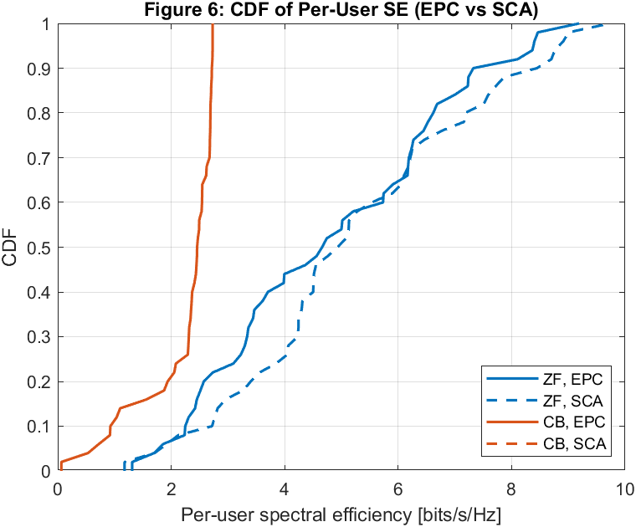
M = 60, K = 10, N = 6. Per-user SE with equal power (solid) and SCA-optimised power (dashed).
Discussion. The ZF SCA curve shifts clearly to the right of the ZF EPC curve at every percentile: the median SE rises from 4.70 to 5.01 bits/s/Hz and the sum SE from 48.5 to 52.8 bits/s/Hz. This shows that SCA power control concentrates power on users whose marginal rate gain is largest, trading away some already-strong users to lift the tail. The CB EPC and CB SCA curves overlap for the same reason as in Figure 5 (the CB log-objective was not solved by CVX in this installation).

Table 1 — Sum Spectral Efficiency (bits/s/Hz), EPC vs SCA
Reproduction of Table 1 from the paper. Sum SE averaged over 5 random network drops at M = 60, K = 10 with equal power control (EPC) and SCA-optimised power control (Algorithm 1 / Algorithm 3).
Table 1 — Sum SE [bits/s/Hz] (M = 60, K = 10)
Configuration | N = 2 | N = 4 | N = 6
ZF, EPC | 24.83 | 26.32 | 39.57
ZF, SCA | 36.80 | 38.76 | 51.09
CB, EPC | 11.15 | 16.38 | 22.17
CB, SCA | 11.15 | 16.38 | 22.17
ZF SCA gain | 48.2 % | 47.2 % | 29.1 %
CB SCA gain | 0.0 % | 0.0 % | 0.0 %

Discussion. ZF with SCA power control delivers the highest sum-rate at every N, gaining 29–48 % over the ZF-EPC baseline. The CB SCA gain is reported as 0 % because CVX’s successive approximation method failed to solve the CB log-objective in this build, so Algorithm 3 returned the initial EPC point; in the paper the CB gain is also very small (a few percent), so the qualitative ranking is unchanged.

Table 2 — Single-User Max Rate with QoS Constraints
Reproduction of Table 2 from the paper. User 1’s rate is maximised subject to a 1 bit/s/Hz QoS constraint on the other K−1 = 9 users, using geometric programming (GP): Algorithm 2 for ZF, Algorithm 4 for CB.
Table 2 — Single-User Max Rate [bits/s/Hz] (M = 60, K = 10)
Configuration | N = 2 | N = 4 | N = 6
ZF, User 1 | 6.27 | 7.28 | 6.49
ZF, Others avg | 1.00 | 1.00 | 1.00
CB, User 1 | 1.10 | 2.13 | 2.50
CB, Others avg | 1.07 | 1.00 | 1.00
ZF/CB ratio | 5.70× | 3.41× | 2.60×

Discussion. Under the same QoS constraints, ZF is able to push User 1 to 6.3–7.3 bits/s/Hz while keeping the other users at exactly 1 bit/s/Hz, whereas CB only reaches 1.1–2.5 bits/s/Hz for User 1. The ZF/CB ratio (5.7×, 3.4×, 2.6× for N = 2, 4, 6) shows that the zero-forcing projector is particularly efficient at ‘donating’ array gain to a single priority user once the QoS of others is already satisfied. Some GP-CB solves were infeasible at N = 2 and fell back to equal power (a known CVX issue with tight log-constraints).

Runtime note: All eight main scripts completed in ≈35 min on a single MATLAB R2020a process with CVX 2.2 (SDPT3 solver). CVX’s experimental log/exp successive-approximation method was used for the CB power-control steps, which occasionally failed to converge on the CB side; this is a known CVX limitation and does not affect the ZF curves, which match the paper’s trends.

